Configure running project

Note: This guide assumes the Drupal project is set up.

If not, please read “README” first.

## A] Configure Drupal

On arrival, Drupal should present you a setup page starting with choosing language:

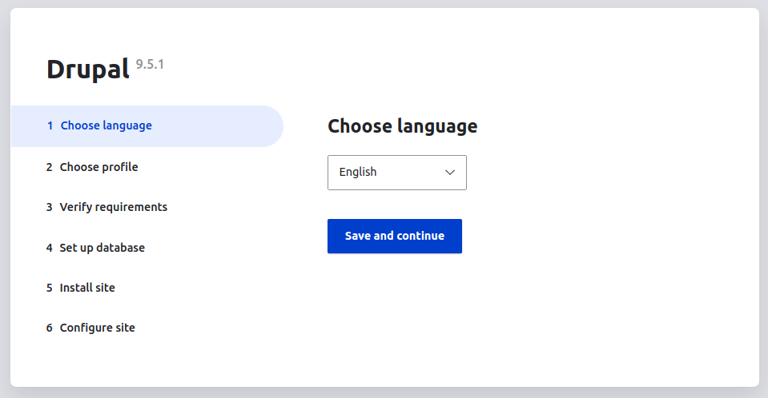

Choose the “Standard” profile:

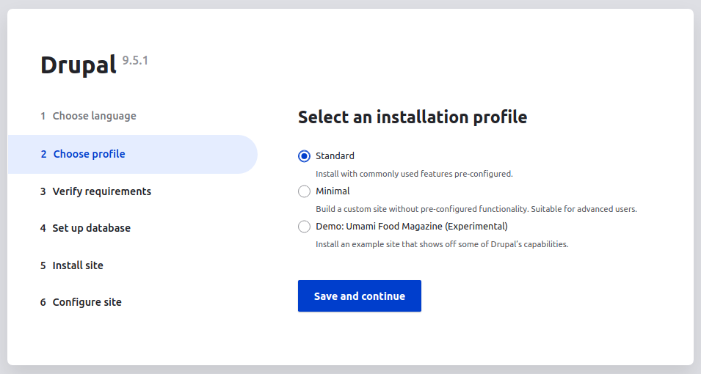

On “Configure Site”, fill in necessary parameters

By the end of this section, you should be presented with a base home page

|  |
| --- |
|  |

## B] Setting up theme

To find themes, go to admin menu above and click on “Appearance”



Since this repository has a “PEP CCMP Bootstrap 5” theme, it should be found in “uninstalled themes”. Click on “Install and set as default” to use the theme.

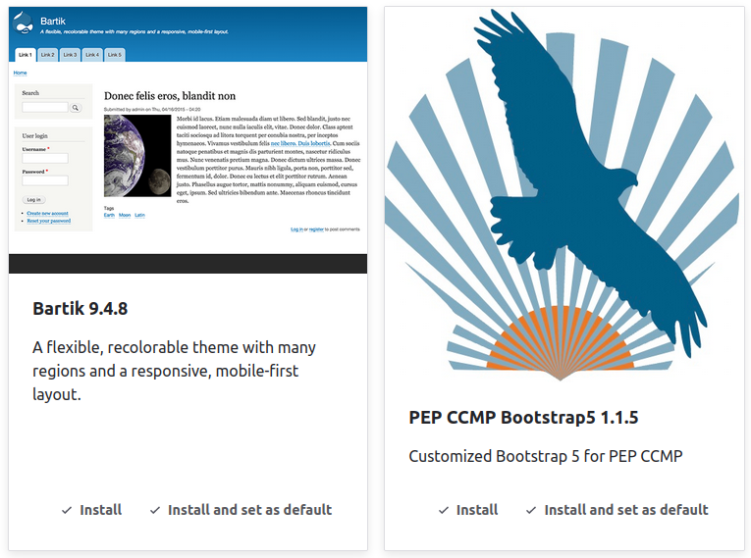

If the installation is successful, there should be a message for successful installation:

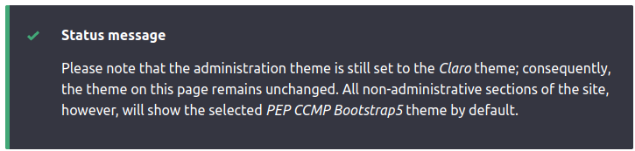

To test this theme, go to the site page and the design should have changed:

|  |
| --- |
|  |

## C] Setting up modules

To find modules, go to the admin menu above and click on “Extend”



Since this repository has “PEP Home” and “PEP Project Tracking”, search “PEP” into the search bar and there should be a search result. Check the modules: “PEP Home” and “PEP Project Tracking” and install the modules.

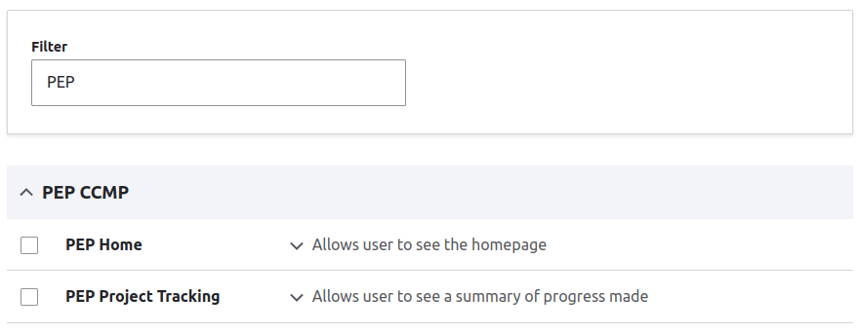

If the installation is successful, there should be a message for successful installation:

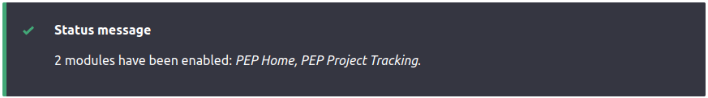

## D] Other settings

Before testing the modules, go to the admin menu above and click on “Configuration”



Then go to “Basic site settings”. It should be on the top of the menu

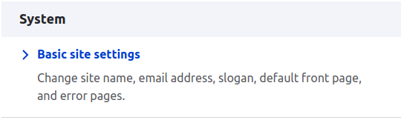

In “Front page”, set the extended URL as “/home” and “Save configuration”

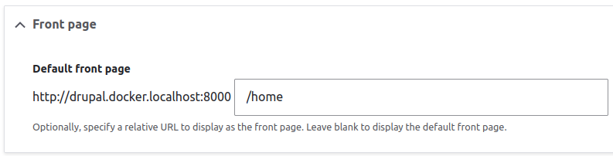

To test “PEP Home” module, click on “Back to site”



It should take you to the homepage of the project

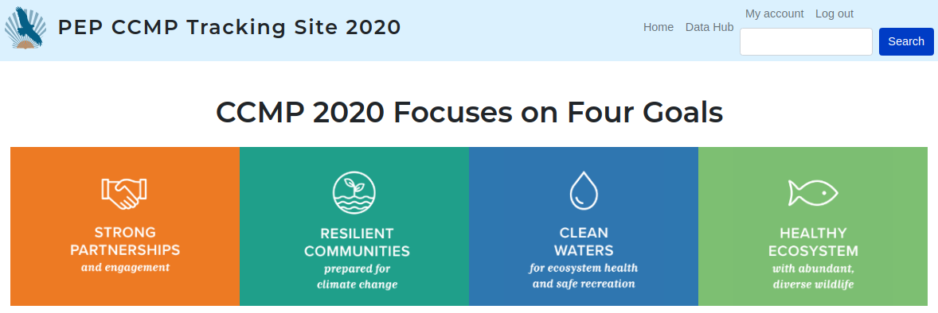

To test “PEP Project Tracking” module, click on any of the four goals below, it should take you to the progress of the goal you clicked on.

To add a clickable carousel to the landing page, refer to the documentation “Make Drupal Carousel”